# **Caremark.com – Medication Coverage & Cost/Copay Website**

|  |
| --- |
| **Scenario/Member Statements** |

My doctor wants to prescribe (medication name) where can I find how much it costs?

My doctor wants to prescribe (medication name) where can I find out if it's covered?

I am looking for a generic for (medication name), does the website have that information?

|  |
| --- |
| **Process Demonstration – Video Walkthrough** |

 Coming Soon.

|  |
| --- |
| **Medication Search** |

1. Hover over the **Plan & Benefits** tab; click **Check Drug Cost and Coverage** OR click **Check Drug Cost** dashboard icon.

**Result: Check Drug Cost and Coverage** page displays:

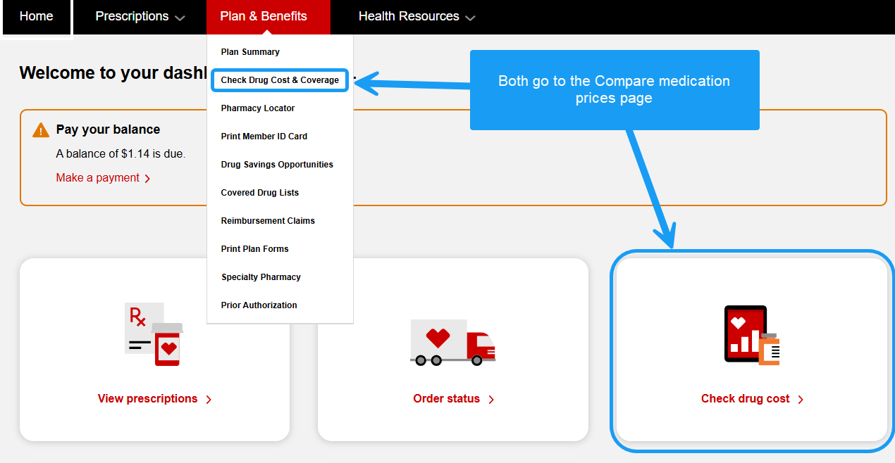

1. Type in drug name or the first 3 letters and choose from the drop-down.

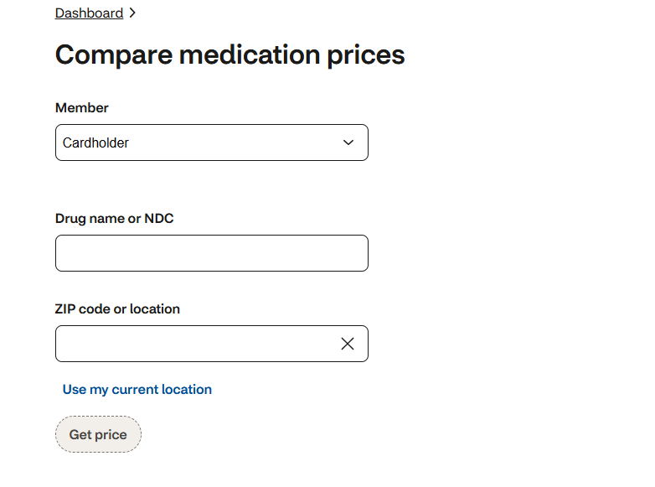

1. Choose Drug.

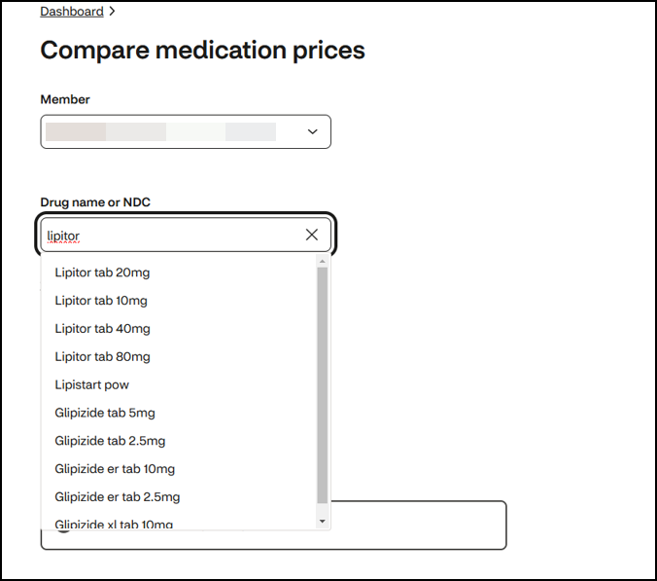

1. Click **Get Price**.

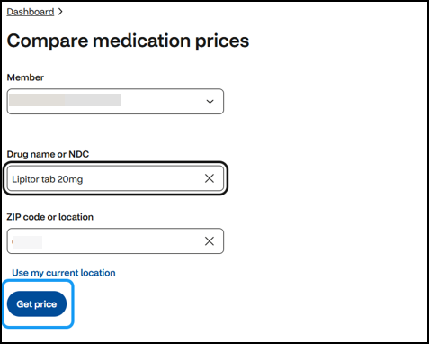

 **5.** Member sees the Price comparison results.

Depending on the medication being priced, the member sees the following:

1. Different day supply across multiple channels. Mail Order, In-Store.
2. If the member searches for a brand and a generic equivalent is available, the screen displays both medications.
3. If the member prices a drug, and it is “not covered,” a price estimate might not be displayed.
4. Members have the option to Request a New Prescription at mail when appropriate.
5. The member can compare pricing for different pharmacies.
6. Covered alternatives and pricing are provided for comparison, if available.

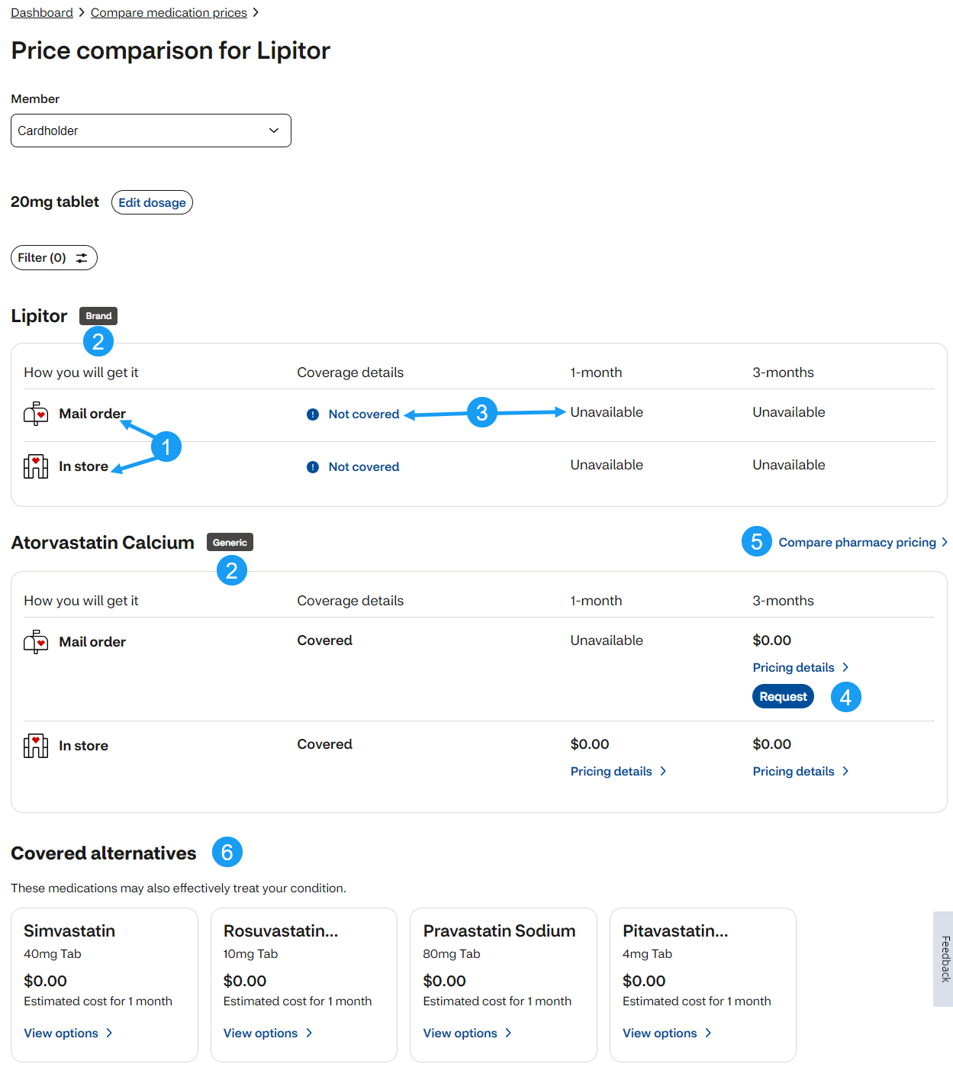

|  |
| --- |
| **Related Documents** |

[Caremark.com - Common Member Assistance Call Types Index](https://thesource.cvshealth.com/nuxeo/thesource/#!/view?docid=947b0b38-401d-4b18-a08e-60348558a9b9)

**Full Details Document:** [Caremark.com - Check Drug Coverage and Cost](https://thesource.cvshealth.com/nuxeo/thesource/#!/view?docid=75429d1c-5347-4d01-8dcb-3dc533de5542)

Not To Be Reproduced Or Disclosed to Others Without Prior Written Approval

**ELECTRONIC DATA = OFFICIAL VERSION / PAPER COPY = INFORMATIONAL ONLY**